CaT Stretcher User Manual

Updated: 2023/09/10 by Steven Wang

GitHub Repository: 3

Prepare the Actuation Unit: 3

Making all Wired Connections & Launching Application 6

CaT V1 6

Setup 1: Using 2 power supplies (recommended) 6

Setup 2: Using 1 power supply 10

CaT V2 12

# GitHub Repository:

<https://github.com/crystalliu314/CaT_Stretcher>

# Prepare the Actuation Unit:

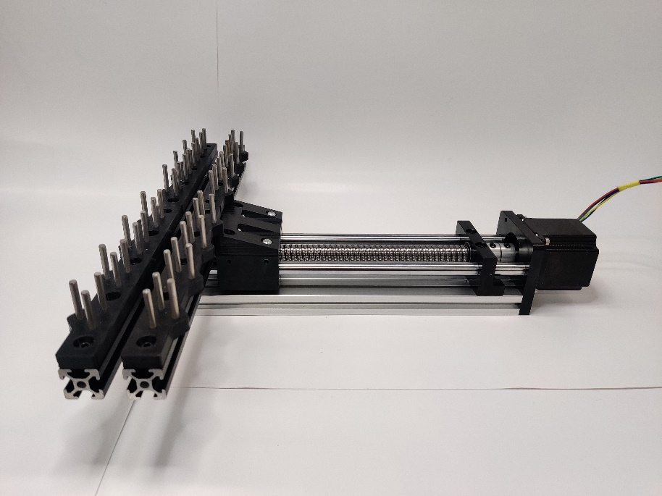

1. Print the following parts:

From GitHub Repo Path: CaT_Stretcher/Mechanical Design/Custom Parts Design Files

/3D Printing/

|  |  |  |
| --- | --- | --- |
| Rail Attachment Bracket | X1 |  |
| PDMS Wells Mounting Plate | X4 |  |

1. Secure the Rail Attachment Bracket to the Rail System using 4X M5x10 screws.

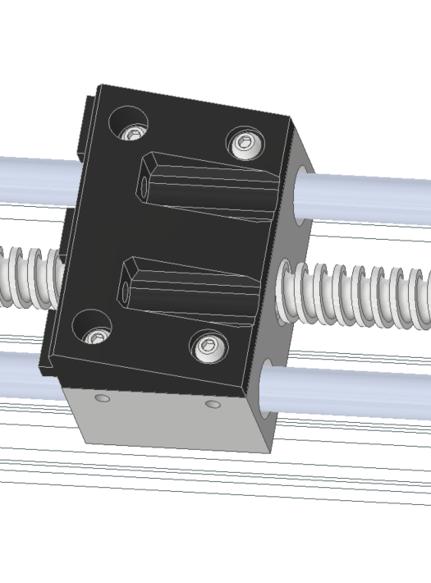

1. Attach an aluminum extrusion to the Rail Attachment Bracket using 2X M5x10 screws and M5 T-nuts (T-nuts slide into the grooves of the extrusion)

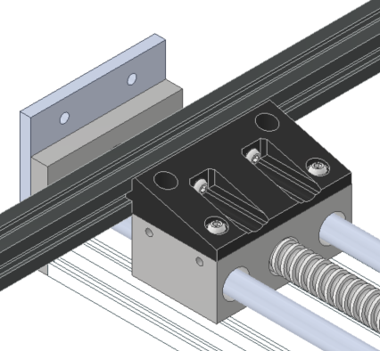

1. Use another pair of M5x10 screws and M5 T-nuts to fix a second aluminum extrusion to the End Attachment Bracket.

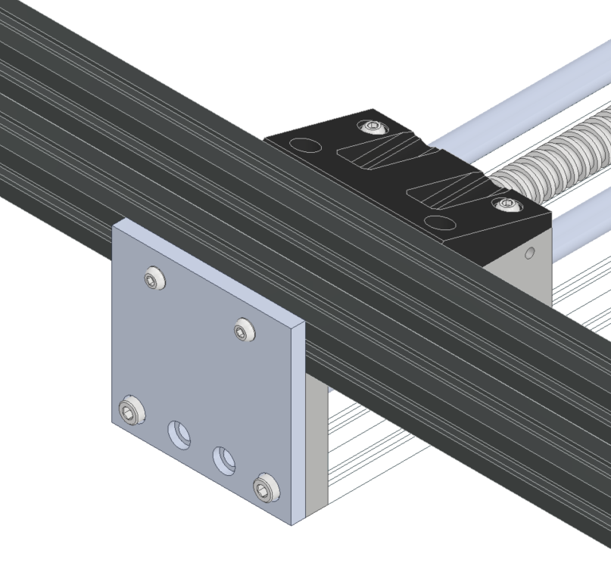

1. Hammer 4X30mm dowel pins into the PDMS Wells Mounting Plates (X4). Note the orientation of the mounting plates.

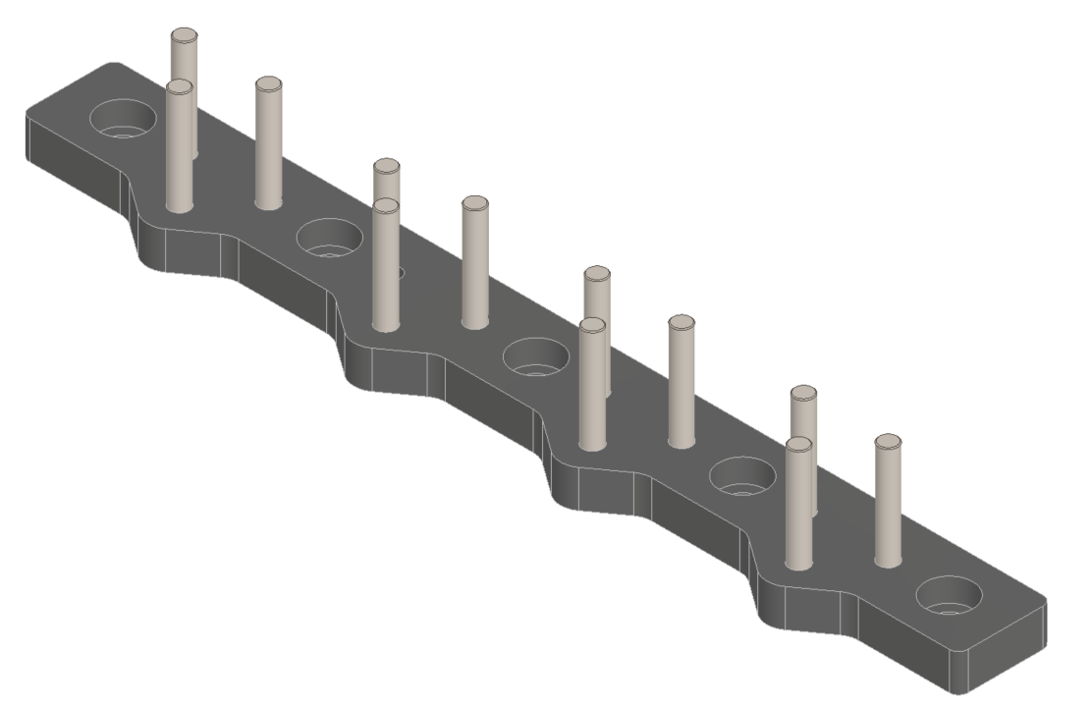

1. Install a pair of PDMS Wells Mounting Plates onto each aluminum extrusion using M5X10 screws and M5 T-nuts. Make sure the orientation of each mounting plate matches picture below.

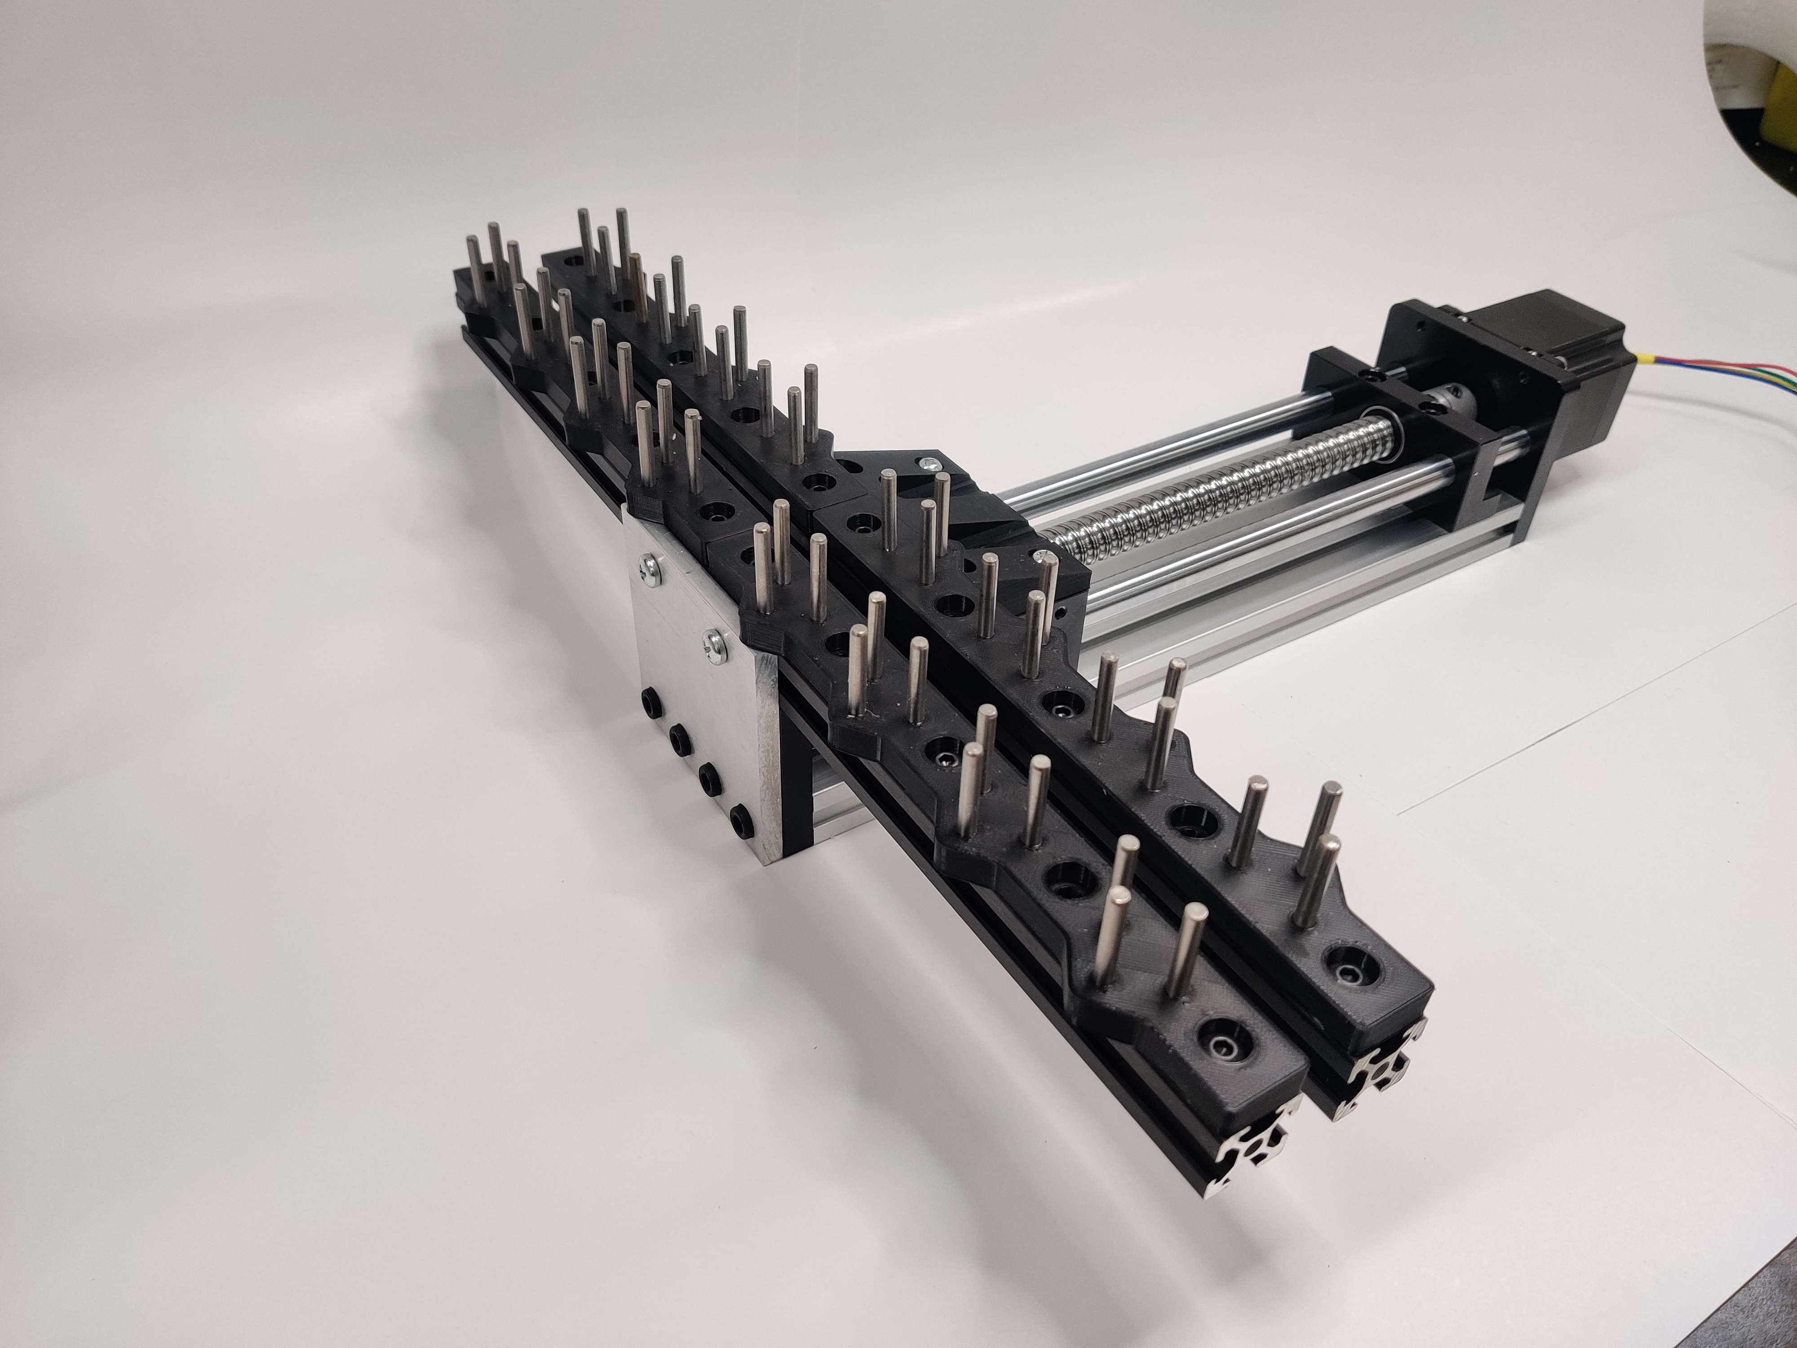

# Making all Wired Connections & Launching Application

## CaT V1

### Setup 1: Using 2 power supplies (recommended)

1. Locate the 12V barrel power supply. Use a flat head screwdriver to make sure the small red dial is set to 12V.

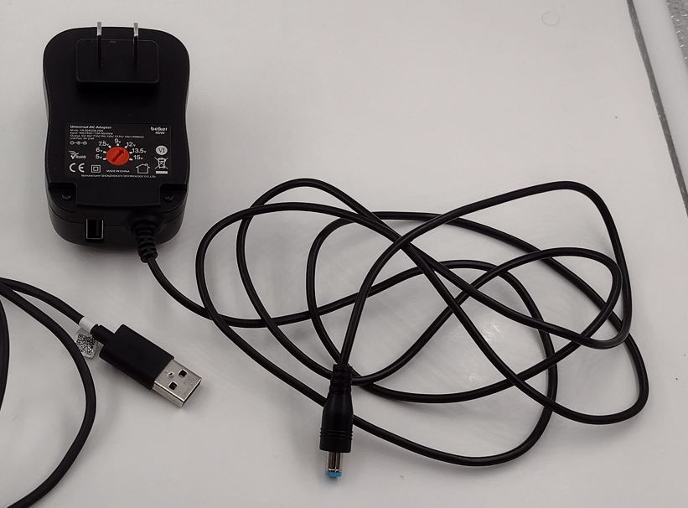

Alternatively, the 12V barrel power supply for CaT V2 can also be used.

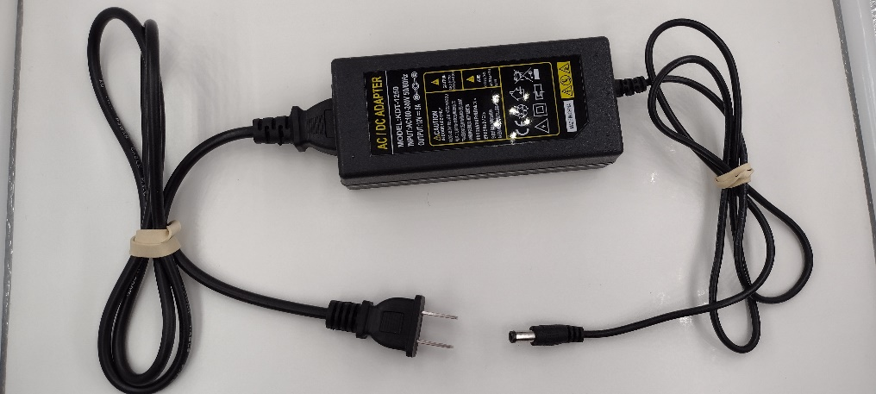

1. Plug the barrel connector into the female port on the control unit.

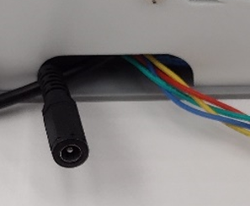

1. Locate the Raspberry Pi USB-C power supply.

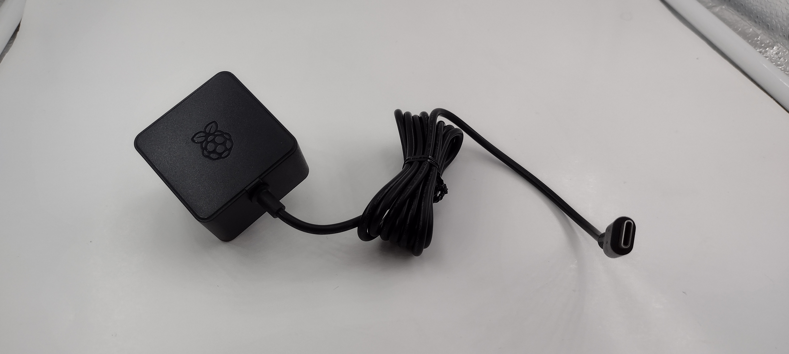

1. Plug the USB-C connector into the Raspberry Pi port (red circle) which can be found looking into the cable cutout on the back of the controller housing.

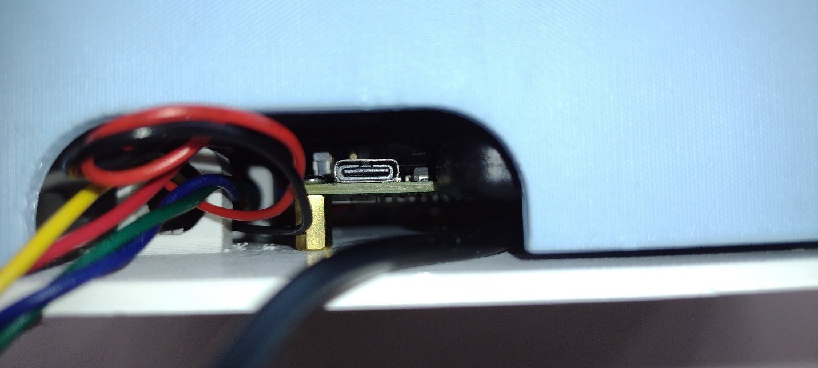

1. Connect the actuation unit motor to the control unit using the green 4-pin port (green circle)

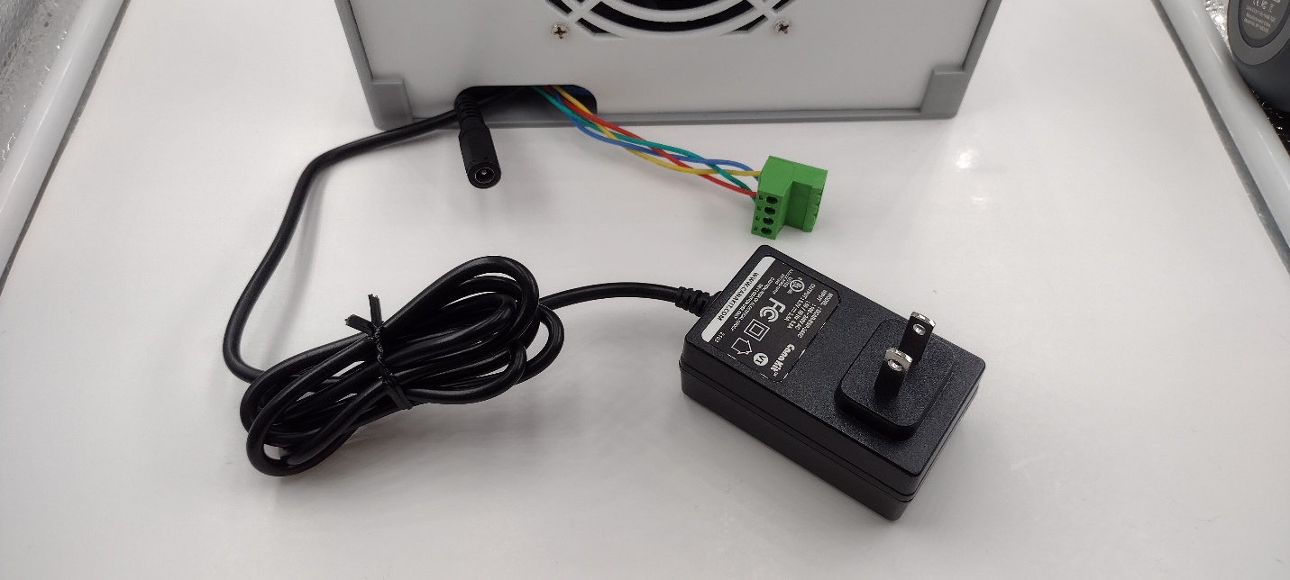

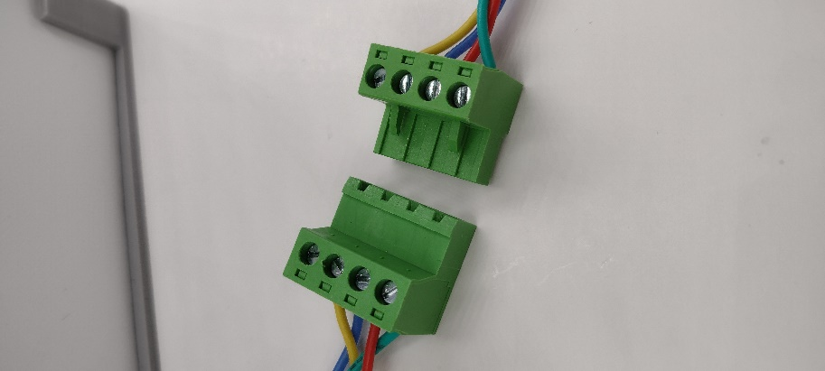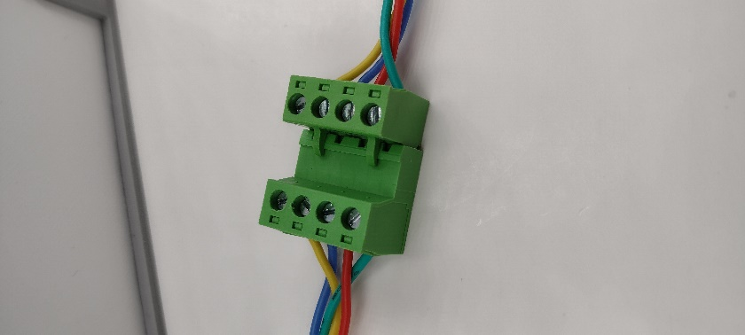

1. Plug **both** power supplies into the wall. The control unit should automatically power on to the screen below. Click into the folder labeled: “application.linux-armv6hf”
2. Double click icon labeled “Cell_Stretcher_UI_Pi_V2”. This will start the user interface application to control the CaT Stretcher.

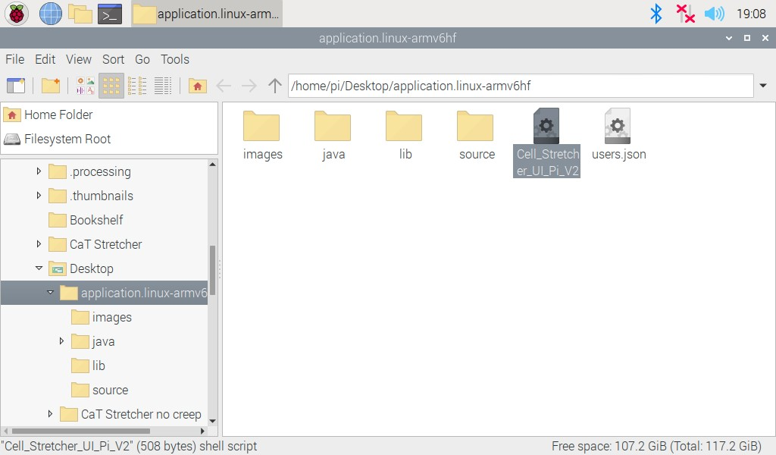

1. When prompted, click “Execute”.

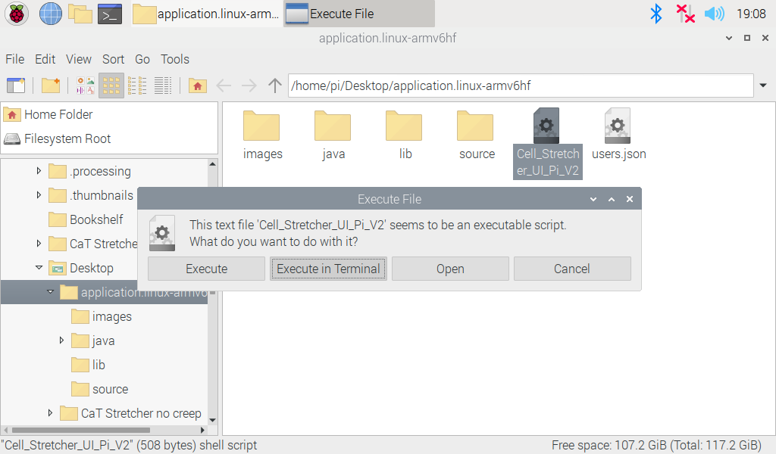

Note: if the following screen is not shown upon launch, close and restart the application.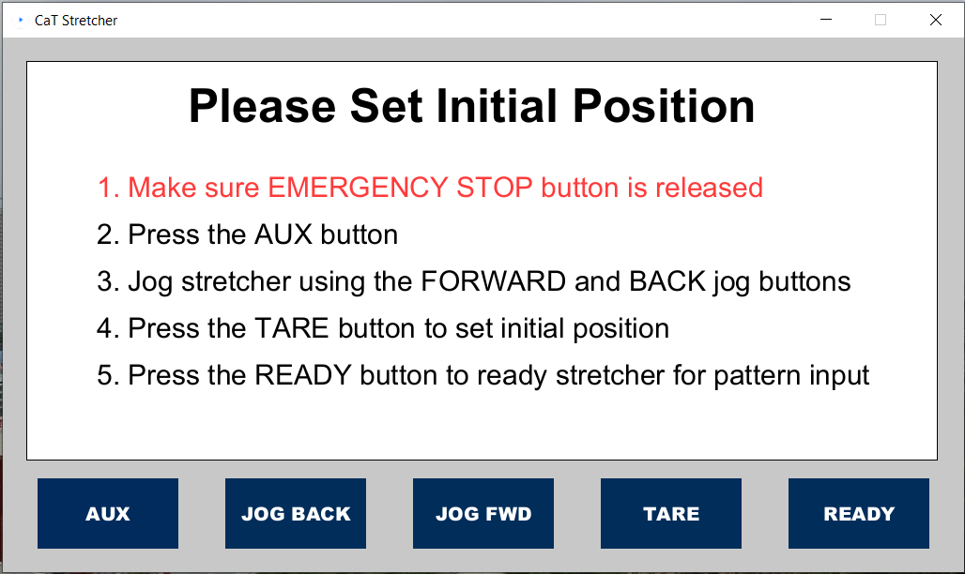

### Setup 2: Using 1 power supply

Disclaimer: The singular power supply is not strong enough to power the Raspberry Pi. The machine will turn on, but you will be prompted with a “low voltage” warning. Machine performance may be negatively impacted. Setup 1 is recommended.

1. Locate the 12V barrel power supply. Make sure the small red dial is set to 12V. Additionally, find a USB-A to USB-C cable. Plug the USB-A connector into the female port on the power supply (red circle)

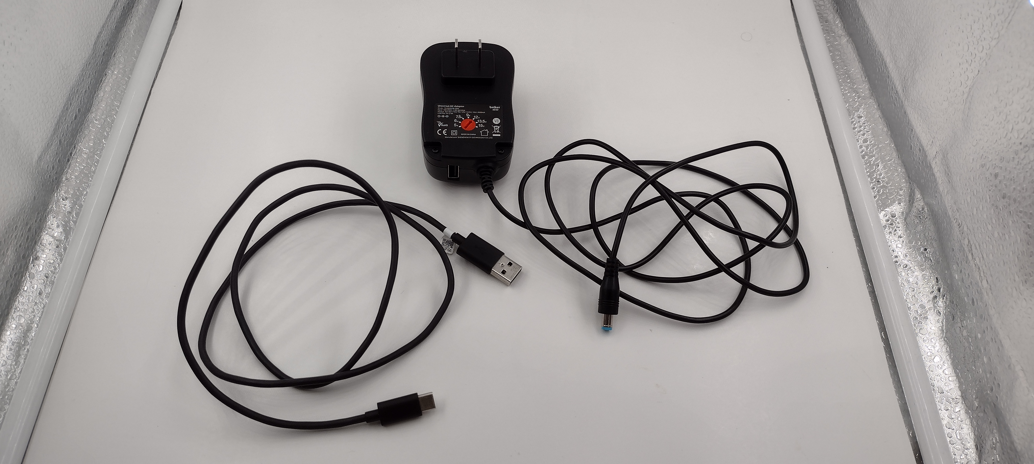

1. Plug the barrel connector into the female port on the control unit.



1. Plug the USB-C connector into the Raspberry Pi port which can be found looking into the cable cutout on the back of the controller housing.



1. Connect the actuation unit motor to the control unit using the green 4-pin port (green circle)





1. Plug the power supply into the wall. The control unit should automatically power on. Continue from **step 6** under **Setup 1**.

## CaT V2

1. Locate the 12V barrel power supply (powers PCB)



1. Connect the 12V barrel supply to the female port (red circle) on the control unit. Also connect the actuation unit motor to the control unit using the green 4-pin port (green circle). Note that the Raspberry Pi has its own power supply (shown below) separate from the 12V barrel power supply.





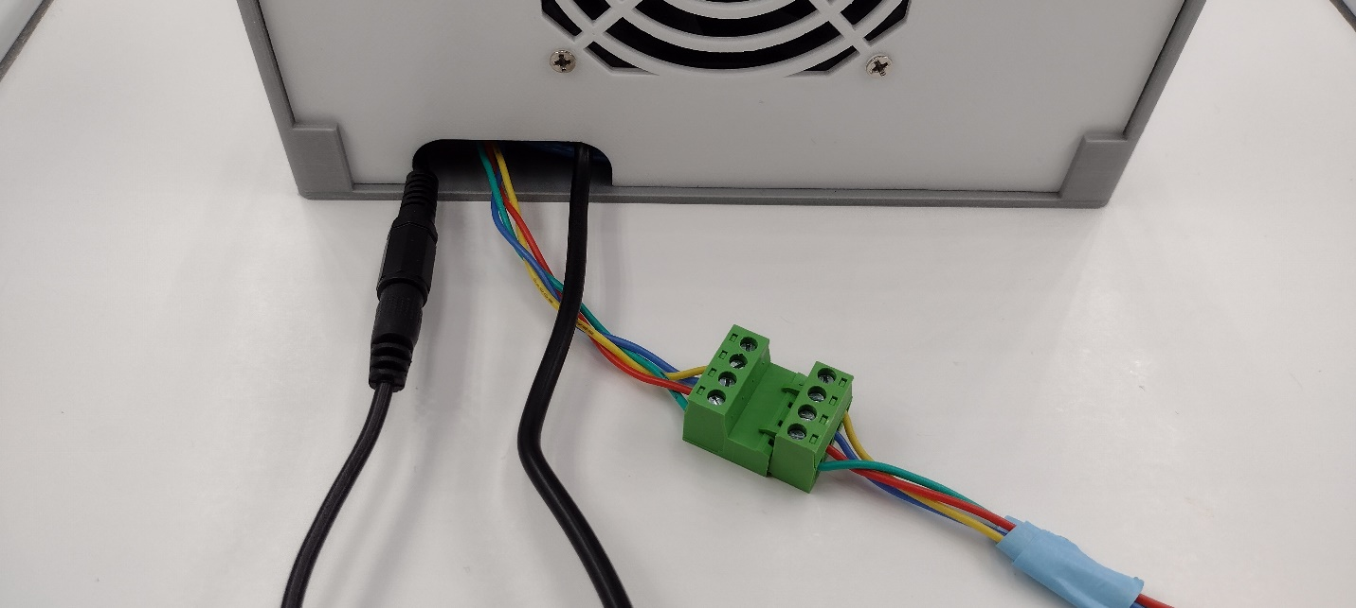

1. Plug **both** power supplies into the wall. The control unit should automatically power on to the screen below. Click into the folder labeled: “application.linux-armv6hf”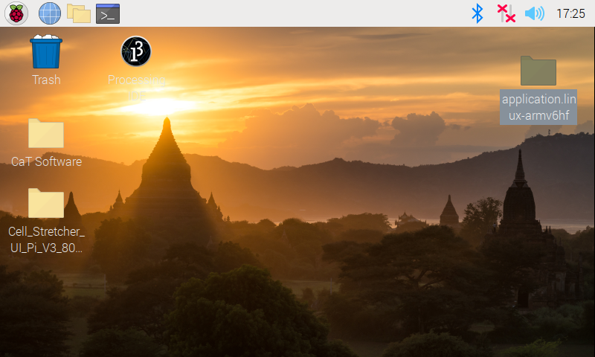
2. Double click icon labeled “Cell_Stretcher_UI_Pi_V3_800x480”. This will start the user interface application to control the CaT Stretcher.

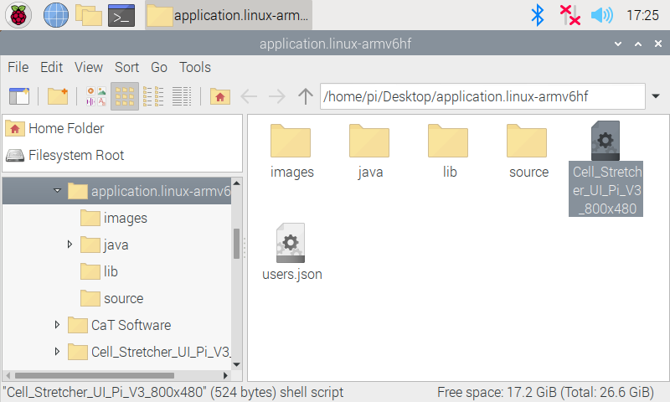

1. When prompted, click “Execute”.

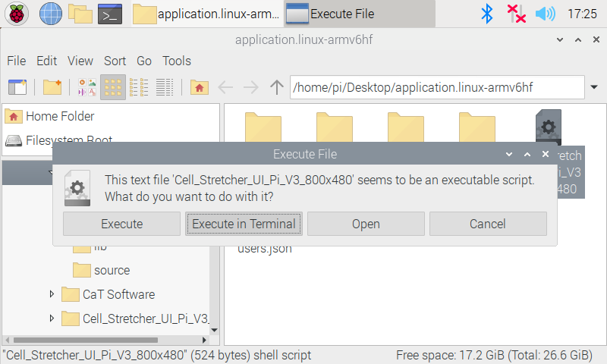

1. Specify the Raspberry Pi serial port connected to the Arduino Uno. Select the option labeled “……USB…” from the dropdown menu. Click OK. The app should launch.

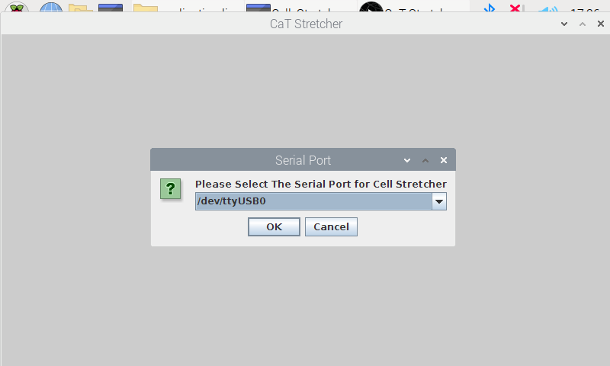

Note: if the following screen is not shown upon launch, close and restart the application.